System Simulation project Istanbul, Turkey, January 6, 2021

**Determining the quality of crops that are grown in different Heinz's farms.**

**Altinbas university**

**Prepared By:**

- Mahmoud Zain Sabto 180501448.  
- Khalid Saud 180501244.  
- Mohammed Saber 170501596.  
- Hakan BERBER 140501024.  
- Rana Hummas Sarwar 180501584.

**Content**

**Introduction Page: 3-4**

**Crop yield Page: 4-5**

**Crop Failure Page: 5-6**

**Methodology Page: 7-10**

**Discussions Page: 11**

**References Page: 12**

**Abstract**

This report gives exclusive insights into a simulation of the yield of farms that are owned by Heinz around the globe (a condiment manufacturing company), the report includes a simulation of how could the farms yield and we also discuss the importance of simulations for companies, the simulation is conducted on a 3-hour production line that determines the ripe, unripe, and spoiled tomatoes and peppers that a farm could yield at the end of a growing season, the tomatoes and peppers are meant to manufacture the 2 most famous condiment: hot sauce and ketchup.

**Introduction:**all food manufacturing companies must know the source of their ingredients that they use to manufacture their product, some companies might have a trustworthy supplier that can provide the company with its requirements, but some companies must have their own first step products (the products in their first form before any kind of manufacturing), that adds a lot of costs and a lot of things to calculate and determine, most important of them is the yield of each farm the company owns, and how to grow the best quality crops with the minimum costs, and also to know which farm is reliable in case of different scenarios, and different goals that the company want to achieve in the future, or in case of shortage in stock of one or more kinds of final products (the product that is ready for sale).

that is why it is important to run a simulation on the yield of each farm while taking into consideration the different characteristics of each farm, and the differences between the required labor and the required resources (costs).

Heinz:The Heinz Company is one of the largest American food handling company headquartered in Pittsburgh, Pennsylvania. it was founded in 1869. Heinz manufactures hundreds and thousands of food products in plants on all around the world from many different continents and markets these products in more than 200 countries. The company think they have the 150 number-one or number-two brands worldwide. with a market share in excess of 50% Heinz ranked first in the US for ketchup.

after 1896, the company started to use its "57 Varieties" slogan; it was inspired by a sign advertising 21 styles of shoes, at the time the Heinz company was manufacturing more than 60 products but henry Heinz picked the number 57 instead. In February 2013, Heinz decided to be sold to Berkshire Hathaway and the Brazilian investment firm 3G Capital for $23 billion. On March 25, 2015, Kraft announced its merger with Heinz, made by Berkshire Hathaway and 3G Capital. This made the Kraft Heinz Company the fifth-largest food company worldwide. on June 18, 2015, Berkshire Hathaway became an owner of the majority of Heinz. After using a warrant to acquire 46 million shares of common stock for a total price of over $461 million, causing an increasing to its stake to 52.5%.Heinz was named by the name of its founder "Henry J. Heinz", he was from Germany, but he was an immigrants in the United States and born there. His father was originally from Kallstadt. in 1869, Henry J. Heinz used to pack foodstuffs on a small scale at Sharpsburg, Pennsylvania. At that time, he founded Heinz Noble & Company with a friend, L. Clarence Noble, and began selling horseradish. The first item in Heinz and Noble's Brand was his mother recipe for horseradish. Heinz at a young age started to manufacture the recipe in his father's former house basement. after a few tries to save the company, it went bankrupt in 1875. After a year he decided to start a new company, F & J Heinz, with his brother and his cousin. The first product that the company started with is Heinz Tomato Ketchup. Till The company started to grow. In 1888, Heinz agreed to buy his two partners share and reorganized the company as the H. J. Heinz Company. in 1896 Its famous slogan was introduced by Heinz. Inspired by an advertisement he saw in New York City; the number was picked at random by Heinz because he liked the sound of it.

**Crop yield**Crop yield in agriculture, which is called “agricultural production” refers to both the measure of yield per unit of cultivated land area or the generation of seeds of the same type of plant, for example if three grains are harvested for each seed, the yield of the crop is 1:3 This number is considered by agricultural engineers as the minimum for preserving humanity. One of the three seeds must be set aside for the next planting season, and the farmer consumes only the remaining two. Or one for human consumption and the other for livestock feed. With the increase in the surplus, With the increase in surplus, the more livestock will increase and maintain thus, increase the economic and physical welfare of the farmer and the welfare of his family. this resulted in improved stamina, better health and more efficient work. In addition, the greater the surplus, the more livestock such as horses and oxen, which are supported and devoted to work and to provide manure and thus reduce the burdens of the farms. The increase in crop yields means that there is a need for a small number of manpower on the farm, thus liberalizing industry and trade, and here in turn led to the formation and growth of cities. the formation and growth of cities means an increased demand for food by non-farmers and their willingness to pay money for that, and that led the farms to innovation and intensive agriculture. Demand or creation of new or improved agricultural tools and the search for improved seeds that have improved crop yields, allowing the farmer to increase his income by bringing more food to the non-farmer (city). Thus, a farmer is allowed to raise his income for more foodstuffs for the commercial markets.

 The yield is expressed in different ways depending on the shape of the expected harvest.  
• In the case of a cereal crop such as wheat, barley, grain corn, where we are only interested in harvested grains, we speak of yield in a unit of weight on a unit of area. For example, we will use the quintal per hectare (q / ha).  
• In the case of a forage crop where the crop is harvested for its dry matter such as meadow grasses, corn for silage use, the yield will be expressed in units of dry matter weight.  
• In the case of vines, for example, the yield is calculated in terms of the quantity of wine produced per unit area. We will therefore speak in volume relative to the cultivated area. The most used unit is hectoliter per hectare.  
• It is also possible to calculate the final production yield of the crop, for example for rapeseed or sunflower, in the volume of oil per hectare.

**Crop Failure**

Crop failure means when all or most of the crops on a farm are wasted and lost. The result of it cause to lower the farmers’ income, decrease the availability of food for consumption, also destructively affect the economy, mainly if the country has an agriculture-dependent economy.

**Causes of Crop Failure**

**1- Climatic Conditions**

Adverse climatic conditions are the most important cause of crop failure. Adverse weather conditions involve situations that are too severe for crops to survive, as well as exceedingly cold or extremely hot temperatures. These adverse weather conditions trigger the crops to either dry out due to the burning sun or fail to grow and freeze due to cold conditions.

**2- Unpredictable Weather Conditions**

In the past a few years, the climatic and conditions have been impossible to predict. The cycle of the farming seasons has been interrupted by the continuous change in weather conditions. For example, a long period of drought, long wet season, floods, and full change of season. The unpredictable weather is a result of global warming and human activities.

**3- Pests and Diseases**

There are several pests that harm the growth of crops. Some of them tend to be costly to curb. For example, most farmers on the world will watch the crops being consumed by pests, for instance armyworms, Black cutworm, and Asiatic Garden beetles just because they can't afford to purchase pesticides. There are some diseases that cause the crop to fail. Some of them involve leaf blight, Pythium, and southern rust. Pest and diseases, if not discovered and stopped early enough, may cause a huge crop failure.

**4- Poor Farming Practices**

Bad farming ways and techniques will also cause crop failure. The poor farming methods are mainly is a result of low knowledge of modern farming techniques and absence of funds to adopt the technology in farming. The use and the practice of new and improved farming methods cut a long way in reducing crop failure.

**5- Human Activities**

There are many human activities that tend to harm the wealth of the crops. Use of severe chemicals may lead to fading of the crops. Other behaviors that could cause crop failures involve bad disposal of industrial waste products which could increase the amount of the greenhouse's gas in the environment. The result of these gases, such as sulfur dioxide, cause an acid rain and blockage of leaf pores. Which make the crop to wilt and crop failure.

**6- Neglect by Farmers**

Although not considered a major cause of crop failure, neglect of crops by farmers may cause a disaster. A farmer may plant the crops but fail to look after them and take good care of them, mainly through their crucial stages of growth, such as blooming and fruiting. Abandoned crops is going to cause minimal or no harvest at all.

**Methodology:**

Heinz has a lot of fields where they grow their crops, we will run the simulation on 4 fields that are growing 2 different crops to manufacture ketchup sauce and chili sauce (tomatoes, and peppers) while considering different scenarios that each field might face, let’s assume that their fields are in (Turkey, US, Canada, and South Korea), because of different weather and soil conditions, it is better to plant peppers at different places and it is better to plant tomatoes at other different places, the percentages of what each crop yields in each different location are shown in the table(1) of percentages below (the data on that is not so clear, so the percentages are just estimates), **SIDE NOTE: ( the simulation is correct and the realistic percentages can be calculated on the field by the company that wants to use the simulation).**

|  |  |  |  |  |  |  |
| --- | --- | --- | --- | --- | --- | --- |
| field | unripe tomatoes | ripe tomatoes | spoiled tomatoes | unripe peppers | ripe peppers | spoiled peppers |
| Turkey | 10% | 72% | 18% | 12% | 85% | 3% |
| US | 24% | 70% | 6% | 3% | 87% | 10% |
| Canada | 20% | 68% | 12% | 24% | 65% | 11% |
| South Korea | 8% | 80% | 2% | 11% | 88% | 1% |

**table(1): percentages of each farm quality.**

**our goal is to stimulate the production of these crops.**

**path**

the server is the quality control machine

the server is the quality control machine

a sink for spoiled tomatoes

a sink for unripe tomatoes

a sink for spoiled peppers

a sink for unripe peppers

a sink for ripe peppers

a sink for ripe tomatoes

**Answer:-**

the source is the truck that loads the machine (server) with tomatoes or peppers, the machine checks whether the tomatoes or peppers are green or red or if the tomato or pepper has an imperfection like a crack or if the crop is opened, and then shoots it with an air piston that kicks it off of the production line, and then they are either stored separately or the manufacturing process starts immediately, in our example, the crops are stored for future use in a different facility (sink), the machine can process a lot of crops at the same time (couldn't find the exact information about that but I would estimate 10 crops per second), the way we can determine that is by setting the arrival time for 1 second and 10 entities per arrival in the source and setting the service time in the server for 0 seconds for each server and each source.

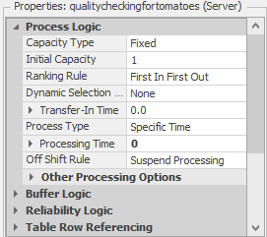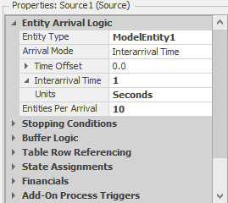

after running the simulation for 3 hours on each country, we will get these results:

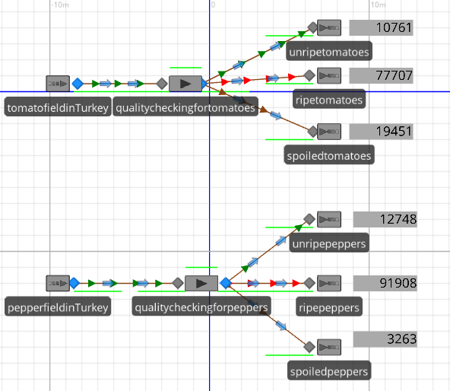Turkey:

the green entities represent the unripe crops, and the red entities represent the ripe crops, and the brown entities represent the spoiled crops.

total unripe crops : 23509

total ripe crops : 169615

total spoiled crops : 22714

rank : 3

|  |  |  |  |  |  |  |
| --- | --- | --- | --- | --- | --- | --- |
| crop | unripe tomatoes | ripe tomatoes | spoiled tomatoes | unripe peppers | ripe peppers | spoiled peppers |
| amount | 10761 | 77707 | 19451 | 12748 | 91908 | 3263 |

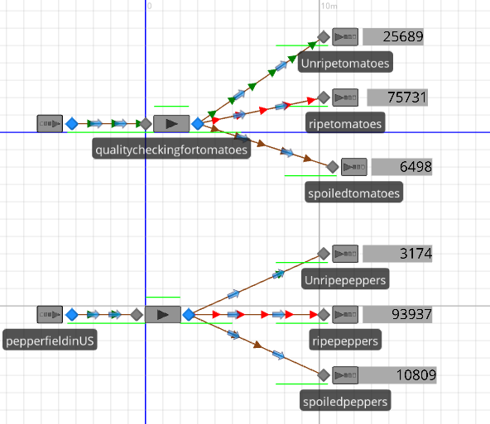US:

the green entities represent the unripe crops, and the red entities represent the ripe crops, and the brown entities represent the spoiled crops.

total unripe crops : 28863

total ripe crops : 169668

total spoiled crops : 17307

rank : 2

|  |  |  |  |  |  |  |
| --- | --- | --- | --- | --- | --- | --- |
| crop | unripe tomatoes | ripe tomatoes | spoiled tomatoes | unripe peppers | ripe peppers | spoiled peppers |
| amount | 25689 | 75731 | 6498 | 3174 | 93937 | 10809 |

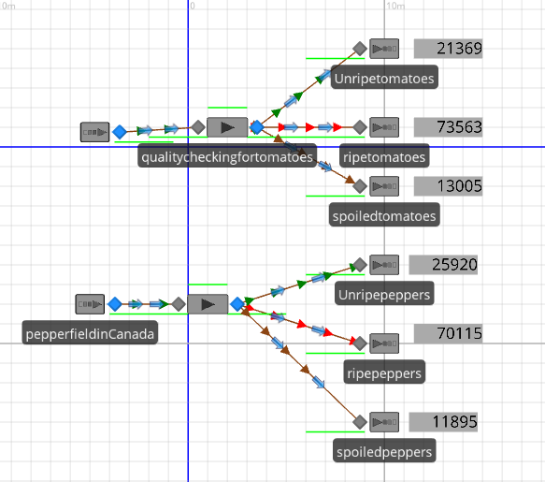Canada:  
  
the green entities represent the unripe crops, and the red entities represent the ripe crops, and the brown entities represent the spoiled crops.  
  
total unripe crops : 47289

total ripe crops : 143678

total spoiled crops : 24900

rank : 4

|  |  |  |  |  |  |  |
| --- | --- | --- | --- | --- | --- | --- |
| crop | unripe tomatoes | ripe tomatoes | spoiled tomatoes | unripe peppers | ripe peppers | spoiled peppers |
| amount | 21369 | 73563 | 13005 | 25920 | 70115 | 11895 |

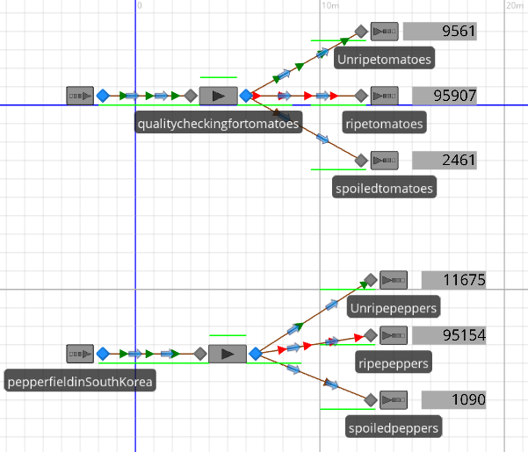South Korea:

the green entities represent the unripe crops, and the red entities represent the ripe crops, and the brown entities represent the spoiled crops.

total unripe crops : 21236

total ripe crops : 191061

total spoiled crops : 3551

rank : 1

|  |  |  |  |  |  |  |
| --- | --- | --- | --- | --- | --- | --- |
| crop | unripe tomatoes | ripe tomatoes | spoiled tomatoes | unripe peppers | ripe peppers | spoiled peppers |
| amount | 9561 | 95907 | 2461 | 11675 | 95154 | 1090 |

**the table of information:**

|  |  |  |  |  |  |  |
| --- | --- | --- | --- | --- | --- | --- |
| field | unripe tomatoes | ripe tomatoes | spoiled tomatoes | unripe peppers | ripe peppers | spoiled peppers |
| Turkey | 10761 | 77707 | 19451 | 12748 | 91908 | 3263 |
| US | 25689 | 75731 | 6498 | 3174 | 93937 | 10809 |
| Canada | 21369 | 73563 | 13005 | 25920 | 70115 | 11895 |
| South Korea | 9561 | 95907 | 2461 | 11675 | 95154 | 1090 |

table(2)**:** the number of the products after the simulation

if further research wore to be included, this report would have been more realistic but that would require Agricultural engineers and expert farmers, and it would also require laboratories and scientific equipment and money and a lot of time, so, the percentages are just estimates.

**Discussions:**

**Why is it necessary to do all that?**

it is always a good thing for the company's HQ to simulate what is happening on its own properties, it is also good to monitor how good is that property doing and how could the company rely on it if needed in some circumstances, it is also good to know how trustworthy are the workers or the responsible people that are working on that property (for example by comparing the profit from last year in comparison to this year while taking into consideration the growth conditions on that property (farm)).

**does this help the company find an optimal solution to a problem?**

yes, it would help the company if it is running short on one kind of sauce, for example, if the company is running short on the stock of hot sauce the company would focus its production on hot peppers, (some kinds of sauce take years of fomentation, the crops are not manufactured and sold immediately) to limit its cost and limit the waste of growing unnecessary crops (tomatoes).

**why wouldn't the company "Heinz" grow all its crops in South Korea (the most efficient country)?**

for multiple reasons, one is that the company makes a lot of products other than ketchup and hot sauce, and some products are only preferred in some countries more than others, and then there is the cost of shipping the product around the world ether as crops for manufacturing or already manufactured at South Korea, and also labeling the product could become a problem if the company manufactures all of its products in one country.

**can we run this simulation on any kind of crops?**

yes, it can run to determine the yield of any kind of crop, but it requires an experienced person who can work on SIMIO to implement the functions and the probability that could affect the growth of crops each year, more realistically than what we did in our project.

**what does the company do with unripe or spoiled crops?**

usually, food manufacturing companies discard all of their unwanted products, it requires more work and labor hours to try and sell it or do something with it that would profit the company, but it could be given for free to nearby farmers and it can be used for livestock or for compost.

**Acknowledgements**

The authors thank the faculty of industrial engineering at altinbas university and employees with whom we have collaborated.

**References**

Byrne, Brendan (March 27, 2013). ["Heinz Set for Shareholder Vote"](http://www.valuewalk.com/2013/03/heinz-set-for-shareholder-vote/). Valuewalk.com. Heinz is as international as they come claiming to have 150 number-one or number two-brands worldwide.

Reynolds, Francis J., ed. (1921). ["Heinz, Henry John"](https://en.wikisource.org/wiki/Collier%27s_New_Encyclopedia_(1921)/Heinz,_Henry_John). [Collier's New Encyclopedia](https://en.wikipedia.org/wiki/Collier%27s_Encyclopedia). New York: P. F. Collier & Son Company.

P. D’Odorico, J. A. Carr, F. Laio, L. Ridolfi, S. Vandoni, Feeding humanity through global food trade. Earth’s Future 2, 458–469 (2014).

Pipes, Richard, Russia under the Old Regime (Charles Scribner's Sons, NY 1974) p.8.  
CHEN, J. C. (2019, November). Crop yield (No. 1). JAMES CHEN. <https://www.investopedia.com/terms/c/crop-yield.asp>.

Cabural, Marie (June 18, 2015). ["Berkshire Hathaway Becomes Majority Owner of H.J. Heinz Company"](http://www.valuewalk.com/2015/06/berkshire-hathaway-becomes-majority-owner-of-h-j-heinz-company/). ValueWalk. Retrieved June 19, 2015.

Misachi, J. M. (2017). What are the causes and consequences of crop failures? Crop Failure, 1.